

**SINHGAD INSTITUTE OF TECHNOLOGY LONAVALA**

**SAVITRIBAI PHULE PUNE UNIVERSITY**

**A**

**PROJECT REPORT**

**ON**

**Temperature prediction linear regression**

**SUBMITTED IN FULFILLMENT FOR SUBMISSION**

**OF**

**Data Analysis**

**SUBMITTED BY**

**Prakhar Jagnani BCB-27**

**Ashutosh sahu BCB-01**

**Muskan Dusad BCB-10**



**DEPARTMENT OF COMPUTER ENGINEERING**

**Sinhgad Institute of Technology, Kusgaon, Lonavala**

**Savitribai Phule Pune University**



**SINHGAD INSTITUTE OF TECHNOLOGY LONAVALA**

**SAVITRIBAI PHULE PUNE UNIVERSITY**

**CERTIFICATE**

This is certified that the Mini Project Entitled

**Temperature prediction linear regression**

**SUBMITTED BY**

**Prakhar Jagnani BCB-27**

**Ashutosh sahu BCB-01**

**Muskan Dusad BCB-10**

**Table of Contents**

|  |  |  |
| --- | --- | --- |
| **Sr.** **No.** | **Title** | **Page** **No.** |
| 1 | Abstract | 1 |
| 2 | INTRODUCTION | 2 |
| 3 | Objective | 3 |
| 4 | Project code | 4 - 5 |
| 5 | output | 6-7 |
| 6 | Conclusion | 8 |

**ABSTRACT**

Weather prediction is a challenging task for researchers and has drawn a lot of research interest in the recent years. Literature studies have shown that machine learning techniques achieved better performance than traditional statistical methods. This paper presents an application of Support Vector Machines (SVMs) for weather prediction. Time series data of daily maximum temperature at a location is analyzed to predict the maximum temperature of the next day at that location based on the daily maximum temperatures for a span of previous n days referred to as order of the input. Performance of the system is observed over various spans of 2 to 10 days by using optimal values of the kernel function. Non linear regression method is found to be suitable to train the SVM for this application. The results are compared with Multi Layer Perceptron (MLP) trained with back-propagation algorithm and the performance of SVM is found to be consistently better.

‘

**INTRODUCTION**

**Project Title:**

***Temperature prediction linear regression***

Weather prediction is a complex process and a challenging task for researchers. It includes expertise in multiple disciplines.The prediction of atmospheric parameters is essential for various applications. Some of them include climate monitoring, drought detection, severe weather prediction, agriculture and production, planning in energy industry, aviation industry, communication, pollution dispersal etc. Accurate prediction of weather parameters is a difficult task due to the dynamic nature of atmosphere. Various techniques like linear regression, auto regression, Multi Layer Perceptron, Radial Basis Function networks are applied to predict atmospheric parameters like temperature, wind speed, rainfall, meteorological pollution etc. It was found that the non linear operator equations governing the atmospheric system are the ones who can better understand the dynamics of atmosphere. In the recent past many forecast methods have been developed using Artificial Neural Networks

**OBJECTIVE:**

* Predict the Temperature by using linear regression.
* Predict the graph of temperature.
* Predict the outcome or future Temperature in advance.

**PROJECT CODE:**

#Importing the libraries

import numpy as np

import matplotlib.pyplot as plt

import pandas as pd

#Importing the dataset

dataset = pd.read_csv('nottem.csv')

X=dataset.iloc[:,:-1].values

y=dataset.iloc[:,1].values

#Spiltting the dataset into the training and testing set

from sklearn.cross_validation import train_test_split

X_train,X_test,y_train,y_test=train_test_split(X,y,test_size=1/3,random_state=0)

#Fitting Sample Linear Regression to the training set

from sklearn.linear_model import LinearRegression

regressor=LinearRegression(normalize=True)

regressor.fit(X_train,y_train)

#predicting the test set result

y_pred=regressor.predict(X_test)

#Visulasing the training set results

plt.scatter(X_train,y_train,color='red')

plt.plot(X_train,regressor.predict(X_train),color='blue')

plt.title('Time Vs Tempreature(Training Set)')

plt.xlabel('Time')

plt.ylabel('Temprature')

plt.show()

#Visulaize the Test set results

plt.scatter(X_test,y_test,color='red')

plt.plot(X_train,regressor.predict(X_train),color='blue')

plt.title('Time Vs Tempreature(testing set)')

plt.xlabel('Time')

plt.ylabel('Temprature')

plt.show()

***OUTPUT***

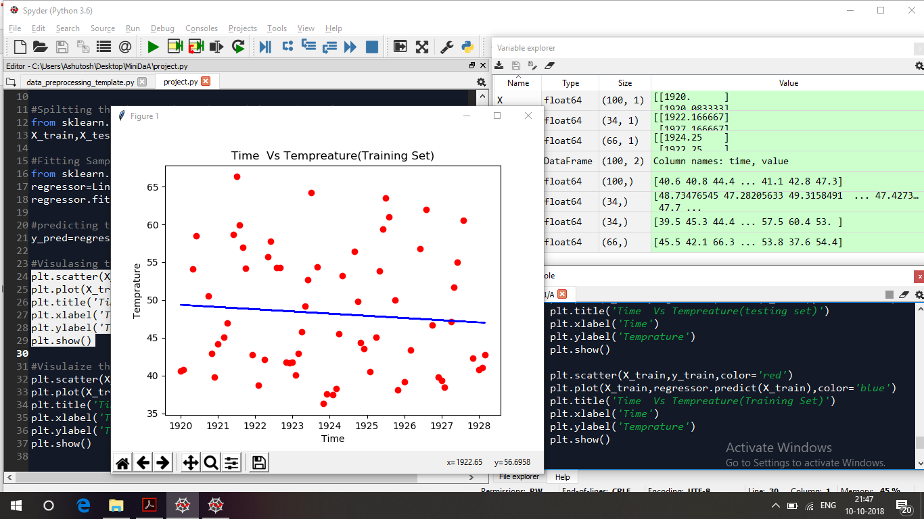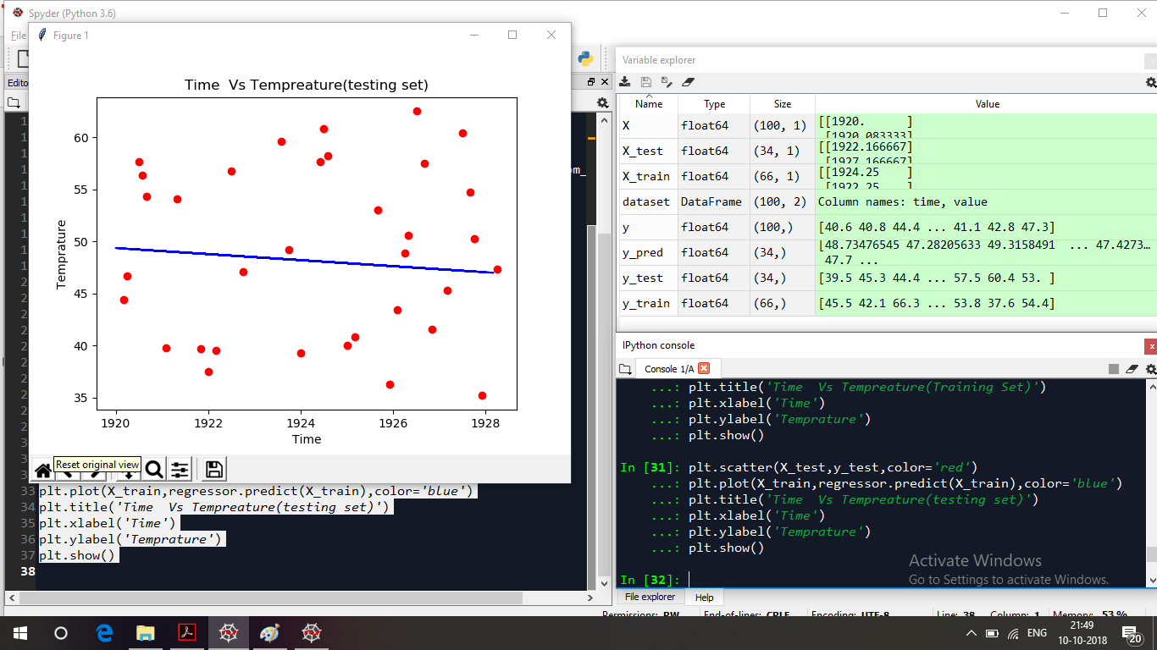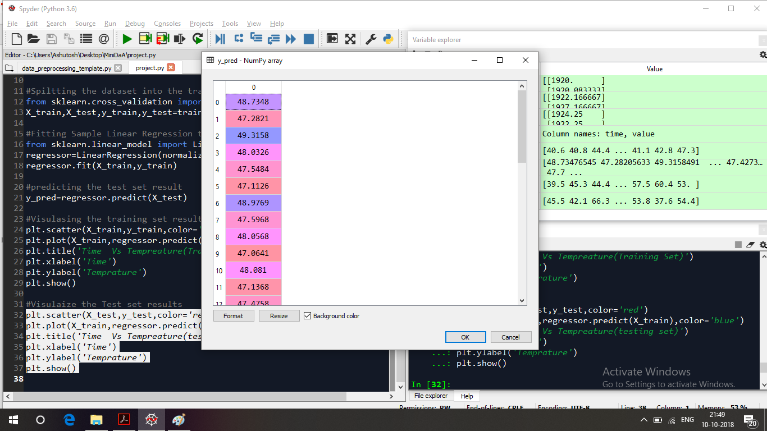

**CONCLUSION:**

An application of linear regression for atmospheric temperature prediction is presented in this paper. The performance of linear Regression was compared with MLP for different orders. The results obtained show that linear Regression performs better than MLP trained with back propagation algorithm for all orders. It was also observed that parameter selection in the case of SVM has a significant effect on the performance of the model. It can be concluded that through proper selection of the parameters, linear Regression can replace some of the neural network based models for weather prediction applications.